The Battle of the Neighborhoods – Part II

By L. Sliwinski

1. **Introduction**

The Business Problem is that we would like to determine where it is most opportune to place certain venues and to determine the frequency of most categories of venues in the Toronto neighborhoods. This may use a clustering approach and a frequency approach, so that we can determine where most venues are grouped, if any groups are present, and determine any business prospects based on that. The most salient question is where to place a specialty foods store which sells imported foods. The clientele of such a store would be a more upper-class citizen with the income to support such a habit, assuming it is a part of their normal food intake. Therefore, it is rational that the best location to place such an establishment would initially be away from those cheaper fast food establishments that would characterize the lower-income and middle-income neighborhoods of Toronto, Ontario, Canada. Of course, the dissemination of fast food establishments is not exclusively limited to only lower-income and middle-income neighborhoods, as upper-income neighborhoods also contain establishments of this type, but the logic is that people with a better taste in food will presumably locate their living spaces in places (i.e. neighborhoods and boroughs) where the delimiter of yearly household income is measured in the concentration of cheaper restaurants and corner stores (think of gas stations). If the concentration of fast food restaurants can be taken as an economic indicator when correlated with the relative wealth index, then the Toronto neighborhoods (minus their boroughs) can be weeded out for their salient characteristics and the relative wealth can be assigned, and the location of the specialty foods store determined. It is worth mentioning that a given borough can contain multiple neighborhoods each having different wealth indexes, so even though a borough may be generally affluent, there may be parts of a borough which are not affluent, and therefore these parts should be avoided for placing a specialty foods store. This analysis will determine this.

1. **Data**

I am sourcing the data from Foursquare.com and I will call the data via the Foursquare API credentials. This is location data. The location data focuses on the neighborhoods in Toronto that have certain venues, and the classification will be up to me. I have decided to provide the latitudes and longitudes of the various places in the data, as well as to import all of the Python packages that would necessitate this data. This allows me to use the Wikipedia page data to refine, classify, categorize, and utilize the Toronto neighborhood location data in a way that first into my analysis. If it were not for the latitude and longitude of the data, I would classify my location of the specialty foods store by wealth index only.

1. **Methodology**

My methodology has been to create clusters and sort the Toronto neighborhoods in the absence of their latitudes and longitudes. It has been easiest to classify according to borough and to see what, if any, venues are clustered therein. From there, I have analyzed the density of certain venues and their frequencies. It turns out that the k-clustering algorithm allows you to create a selected number of clusters which can be used to classify the venues in each of the Toronto boroughs. The use of k-means clustering and the various Foursquare data from which my analysis is drawn is the means by which I am coming to my conclusion. In addition, the relative latitude and longitude of each Toronto classification has been included to determine the areas of relative wealth, and/or the location of the places with the highest concentration of certain venues. What is more, the concentration of bars, gas stations, and intersections has to be sorted out of the general analysis since these are synonymous with lower levels of wealth or with a lack of gentrification. Regardless, even upper-income neighborhoods will have some of these features, albeit in presumably lesser proportions.

1. **Results**

My results have been such that most boroughs are suited to fast food venues, seconded by coffee shops. It appears that pizza places and other venues of similar vein are third common and less common than other venues of a similar nature. I have the result that putting a specialty foods store in boroughs and preferably in neighborhoods (the smaller-level version of boroughs) where fast food joints are not common is the most logical step, and choosing a borough with coffee shops and similar upscale eateries is a more sound decision. This includes the boroughs of North York, Downtown Toronto, York, Toronto, Queen's park (Toronto), Mississauga, and East Toronto. The places with the least proclivity to place a sound specialty foods store include all of the other boroughs. The list of boroughs, neighborhoods, and types of venue below highlight all of the neighborhoods where coffee shops, restaurants, and hotels are prevalent, which would indicate a higher level of wealth and any potential clients for a specialty foods store. A discussion of the relative wealth indexes would perhaps be in order.

|  |  |  |  |  |
| --- | --- | --- | --- | --- |
| **Borough** | **Neighborhood** | **Type of Venue** | **Average Household Income** | **Median Household Income** |
| North York | Hillcrest Village | Coffee Shop | 77,562 | 59,609 |
| North York | Fairview | Coffee Shop | 43,123 | 39,300 |
| North York | Henry Farm | Coffee Shop | 70,416 | 56,644 |
| North York | Oriole | Coffee Shop | N/A | N/A |
| North York | Bayview Village | Coffee Shop | 90,385 | 56,195 |
| North York | Silver Hills | Coffee Shop | N/A | N/A |
| North York | York Mills | Coffee Shop | 1.2 million | N/A |
| North York | Newtonbrook | Coffee Shop | 81,685 | 60,459 |
| North York | Willowdale | Coffee Shop | 74,139 | 55,986 |
| North York | Willowdale South | Coffee Shop | N/A | N/A |
| North York | York Mills West | Coffee Shop | N/A | N/A |
| North York | Willowdale West | Coffee Shop | 75,778 | 57,733 |
| North York | Parkwoods | Coffee Shop | 71,201 | 56,941 |
| North York | Don Mills North | Coffee Shop | N/A | N/A |
| North York | Flemingdon Park | Coffee Shop | 48,495 | 41,278 |
| North York | Don Mills South | Coffee Shop | N/A | N/A |
| North York | Bathurst Manor | Coffee Shop | 67,963 | 54,314 |
| North York | Downsview North | Coffee Shop | N/A | N/A |
| North York | Wilson Heights | Coffee Shop | N/A | N/A |
| North York | Northwood Park | Coffee Shop | N/A | N/A |
| North York | York University | Coffee Shop | 51,191 | 43,051 |
| North York | Downsview | Coffee Shop | N/A | N/A |
| North York | North Park | Coffee Shop | N/A | N/A |
| North York | Upwood Park | Coffee Shop | N/A | N/A |
| North York | Humber Summit | Coffee Shop | 66,242 | 57,809 |
| North York | Emery | Coffee Shop | N/A | N/A |
| North York | Humberlea | Coffee Shop | N/A | N/A |
| York, Toronto | Del Ray | Restaurant | N/A | N/A |
| York, Toronto | Keelesdale | Restaurant | N/A | N/A |
| York, Toronto | Mount Dennis | Restaurant | 48,859 | 41,062 |
| York, Toronto | Silverthorn | Restaurant | N/A | N/A |
| York, Toronto | The Junction North | Restaurant | N/A | N/A |
| York, Toronto | Runnymede | Restaurant | N/A | N/A |
| York, Toronto | Weston | Restaurant | 48,604 | 39,298 |
| Queen’s Park (Toronto) | Queen’s Park | Coffee Shop | N/A | N/A |
| Downtown Toronto | Christie | Coffee Shop | N/A | N/A |
| Mississauga | Canada Post Gateway Processing Centre | Hotel | N/A | N/A |
| East Toronto | Business Reply Mail Processing Centre 969 Eastern | Coffee Shop | N/A | N/A |

1. **Discussion**

To discuss any observations that I noted, it is that most boroughs are not suited to the placement of a specialty foods store, and that the boroughs that I noted above are those that are the furthest away and have the least frequency of "cheap" eateries and similar establishments, although all boroughs have street networks as one of their defining features. What is more, most boroughs are not suited towards the placement of a specialty foods store, and those that are are few in number. By means of a k-means clustering algorithm where the number of clusters is 10, I have found out how many neighborhoods in Toronto are conducive to the placement of a specialty foods store. It is also worth noting that should we look at average household income or median household income, there is only some correlation between those elements of income and the placement of better existing food establishments such as restaurants, coffee shops, and the lack of prevalence of fast food outlets.

1. **Conclusion**

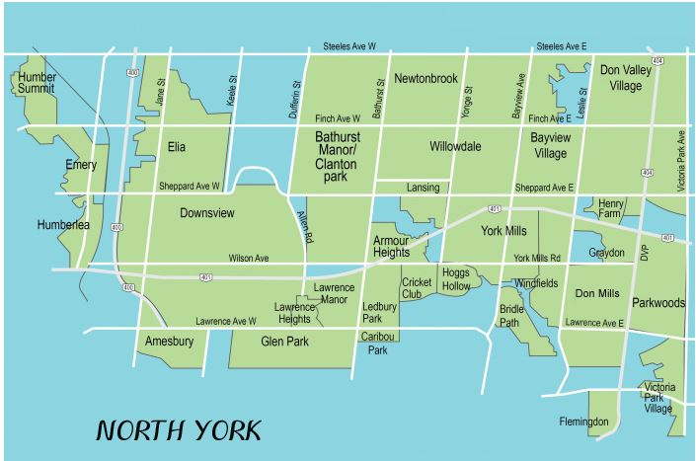

In conclusion, according to my data results, the best places to locate a specialty foods store include those neighborhoods of Humber Summit, York University, Bathurst Manor, Willowdale West, Willowdale, York Mills, Bayview Village, and Hillcrest Village. The concordant boroughs that are the best place to locate a specialty foods store include those boroughs of North York exclusively, when both the relative indexes of coffee shops, restaurants, and hotels indicate the borough as a repository of wealth and the minimum average annual household income of $50,000 is assumed to be the metric, indicating at least a middle-class status by all measures. I have not used the minimum median household income since medians can be misleading and an average gives a better picture of where the “average person” stands economically. A median can have outliers, and an average is less prone to this. In considering also the relative locations of the neighborhoods within the borough of North York, where our income and venue type criteria are satisfied, I find that the neighborhoods in North York are not clustered near each other, but rather occur at the fringes of the borough. We could question if some of the wealth characteristics from some of the surrounding boroughs influence the borderlines of the North York borough. That being said, this concludes my analysis, as I have provided a platform on which to analyze the relative income characteristics of the Toronto neighborhoods, and hereby have isolated one borough as the primary location for a specialty foods store based on the venue characteristics and frequency of that borough/neighborhood, and also the relative wealth index of each neighborhood.

**Bibliography**

<https://www.narcity.com/ca/on/toronto/lifestyle/11-of-the-richest-neighbourhoods-in-the-gta>

<https://www.thefinancialword.com/10-wealthiest-neighborhoods-in-ontario/2/>

<https://www.toronto.ca/city-government/data-research-maps/neighbourhoods-communities/neighbourhood-profiles/>

<https://www.point2homes.com/US/Neighborhood/MI/Fairview-Demographics.html>

<https://www.torontoneighbourhoods.net/neighbourhoods/north-york>

<https://www.torontoneighbourhoods.net/neighbourhoods>